CROTIS AND VOGIS – CROATIAN CONCEPT OF COOPERATIVE MAP PRODUCTION
I. Vilus¹, I. Landek¹, Ž. Železnjak²
¹State Geodetic Administration, Croatia
²Ministry of Defence of the Republic of Croatia
e-mail: igor.vilus@dgu.hr, ivan.landek@dgu.hr, zeljko.zeleznjak@morh.hr

Abstract
Since the space presents the largest wealth of a country along with its population, it is necessary to describe it for the purpose of managing it effectively in the context of promotion the attainable development. Trough CROTIS Project (Croatian topographic information system) standardization of topographic spatial data is comprised, that gives main and detailed solutions of topographic spatial system in domain of data model, their collecting, processing, accuracy, way of presentation, topologic relations and their interchange. The purpose is establishing flexible, useful, simple but quality geo-information system based on modern technologies besides Earth surface modeling with emphasis of functionally important object categories for spatial management.
Republic of Croatia started to build its infrastructure soon after proclaiming independency, with the State Geodetic Administration (SGA) in the forefront of activities, but structured and organized without own production and development facilities. CROTIS is conceived as a basic topographic information system of the Republic of Croatia containing the information needed by every user. The Ministry of Defence of the Republic of Croatia, with the project "Military Geoinformation System - VoGIS" started to build a unique geoinformation system for the Ministry and Armed Forces which is based on the Croatian Topographic Information System made by the CROTIS data model. This system will be in accordance with Croatian and international geoinformation standards and will fully conform to the NATO standards. According to the Preliminary Design, the goal of the VoGIS is the implementation of a geoinformation system that will be the basis for development of all further activities in domain of military spatial data, with special emphasis on creation of military cartographic database and military maps, along with the fulfillment of the Partnership Goals.
Keywords: topographic database, military geoinformation system, military cartography, NATO, FACC, DIGEST, CROTIS, VoGIS
- INTRODUCTION
Republic of Croatia started to build its infrastructure soon after proclaiming independency, with the State Geodetic Administration (SGA) in the forefront of activities, but structured and organized without own production and development facilities.
Trough CROTIS Project (Croatian topographic information system) standardization of topographic spatial data is comprised, that gives main and detailed solutions of topographic spatial system in domain of data model, their collecting, processing, accuracy, way of presentation, topologic relations and their interchange.
In year 2002. CROTIS has become de facto the Croatian standard for establishment of geoinformation systems in topographic domain and is conceived as a basic topographic information system of the Republic of Croatia containing the information needed by every user.
With the project "Military Geoinformation System - VoGIS" The Ministry of Defence of the Republic of Croatia, started to build a unique geoinformation system for the Ministry and Armed Forces which is based on the Croatian Topographic Information System made by the CROTIS data model.
VoGIS is in accordance with Croatian and international geoinformation standards and will fully conform to the NATO standards. The main goal of the VoGIS is the implementation of a geoinformation system that will be the basis for development of all further activities in domain of military spatial data, with special emphasis on creation of military cartographic database and military maps, along with the fulfillment of the Partnership Goals.
- PRODUCTION OF TOPOGRAPHIC DATA
One of the first realized projects that had and still has great influence in further development was cyclic aerial photographing of the whole country (56500 sq km) in scale 1:20000. Scanning those films with photogrammetric scanner, State Geodetic
Administration built the basic source for products such as Digital Orthophoto, Digital Terrain Model and Topographic Data.
Previous activities, for the first time after the independence, enabled the geodetic community in Croatia to be in the position to launch the national project that will methodically cover whole country territory in homogenous, standardized way. After establishing the basic prerequisites, general plan was made that promotes topographic data production.
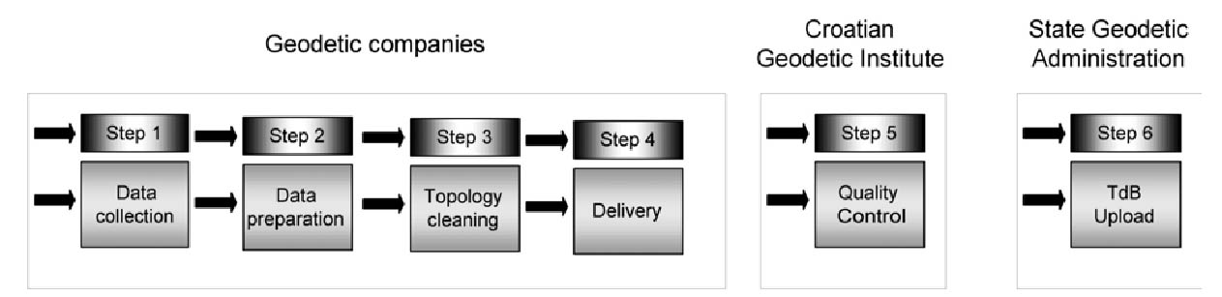
Figure 1: Production of topographic data
The objective of the program of topographic data production is the seamless Topographic
Database (TTB) with positional accuracy of +/-1m on well defined details and +/-3m on other details (State Geodetic Administration, 2001b). By its content and accuracy, the database will be more than appropriate for production of Topographic map 1:25000.
The data should fulfill the wide needs of different users, from infrastructure object designers and urban planners to the professionals in a local community administration. Data should enable presentation of topographic objects in three dimensions, should be structured logically for the simplicity of acquisition, and the aerial images produced in the on-going project of cyclic aerial photo shooting have to be used as the main source.
The complete production process was put in the hands of several largest private geodetic companies and for assuring the homogeneity of quality and for enabling the automated procedures in certain production steps, it was inevitable to prepare very detailed
standards and directions for all production phases. The standardization of the production process was accomplished in the frame of the Croatian-Norwegian Geoinformation project (CRONO-GIP) which goal was "development and implementation of a database within SGA for storage and use of data resulting from the on-going production of new topographic maps in the scale 1:25000" (Rožić et al, 2003).
It is planned that each production step in form of the Product will have to be quality controlled and approved before further usage.
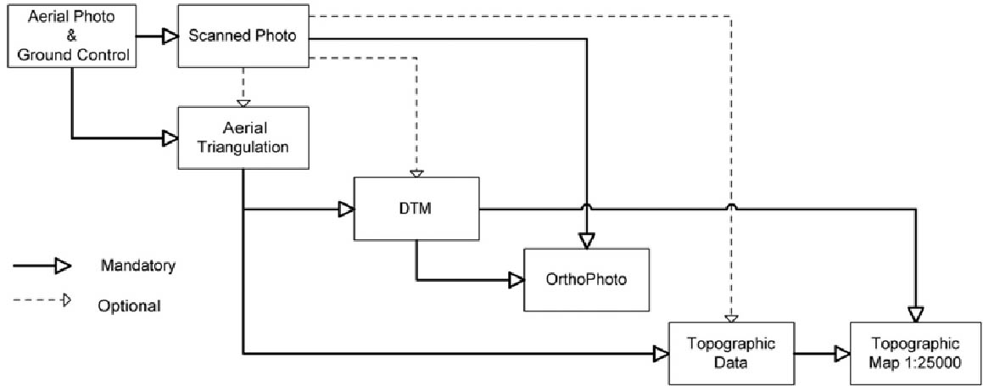

Figure 2: Products and products' predecessors
Standardization of the Products is coming out of the Product Specifications that exist in the
form of documentation and appropriate analogue and digital appendices.
The structure of topographic data is defined by the project Croatian Topographic Information System (CROTIS). Taking into consideration that almost all companies use CAD tools for the photogrametric data collection, the Mapping Catalogue was created that uniquely defines each feature class by the unique combination of graphic attributes. (State Geodetic Administration, 2001a). The Catalogue also defines type of the geometry for feature representation, symbol name for point features and name of the table in the Access database that contains related metadata and attributes.
The Mapping Catalogue is constitutional part of the Topographic Data (TD) specification.
For undoubtful, unique and homogeneous way of transforming topographic objects in stereo-model to the primitive geometric elements in CAD software and for unique attributisation, TD specification contains very detailed instructions called Data Capture Object Selection Criteria that explains topographic objects' definitions, presentation manners and priorities with examples. The result of photogrametric measurement is completed with the data from other sources as well as information (mostly attributes) collected on the field. In the next step, those "raw" data are separated into several files for further compilation. Geometry is connected with the appropriate rows in the appropriate Access tables. Buildings and land cover are layers that must be topologically correct before uploading into the Topographic Database. The Digital Elevation Model (DEM) must be interpolated and delivered in the form of regular grid. The input data are height points, formlines and natural break lines merged with break lines from the land cover data set (road edges, river banks, etc.) (State Geodetic Administration, 2003b).
Final data must be delivered, according to the specifications for Topographic Data and
Digital Terrain Model in five MicroStation design files, one Access database and one text file (Figure 3).

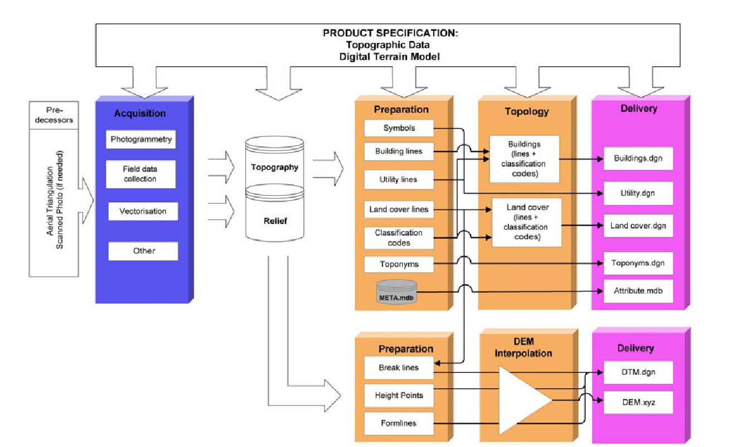
Figure 3: Production of topographic data – acquisition, processing and delivery

- QUALITY CONTROL SYSTEM
After Topographic Data and Digital Terrain Model delivery the process of Quality
Control in Croatian Geodetic Institute starts (Figure 4).
According to definitions of ISO quality elements, subelements, descriptors, evaluation methods and selected tolerances (ISO, 2001) the Quality Plan is developed. Execution of the Quality Plan on Topographic Data and DTM results with the Quality Evaluation Reports.
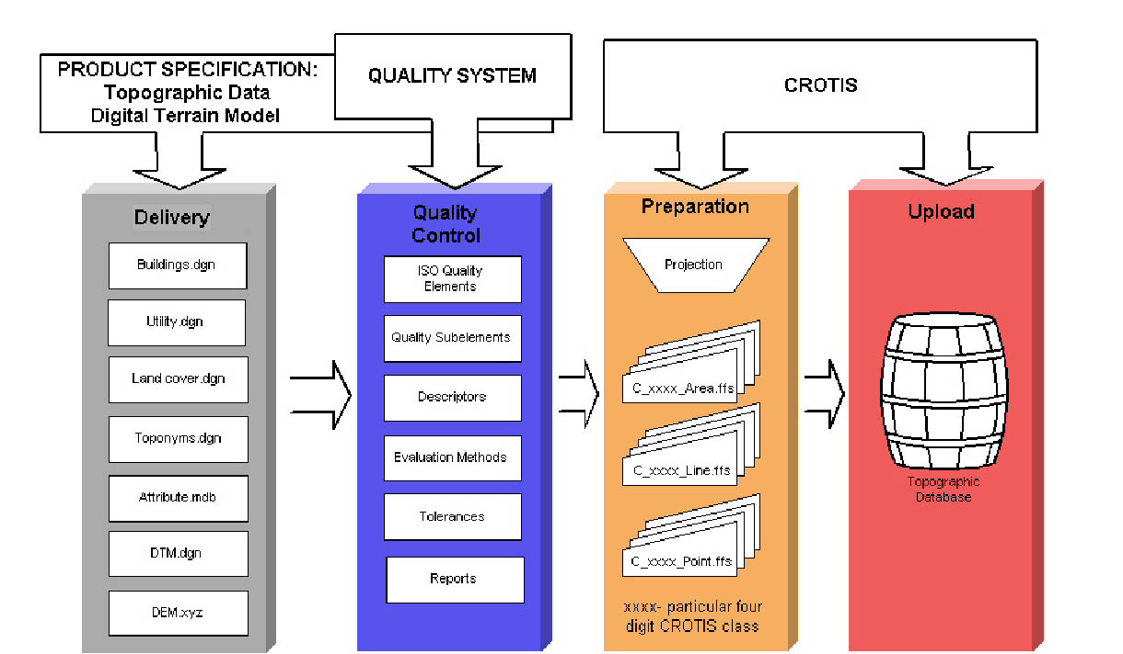

Figure 4: Quality Control in Croatian Geodetic Institute
- VOGIS SYSTEM
Topographic component in VoGIS is result of conformance of the topographic database of the State Geodetic Administration (SGA) and military content to NATO norms. Cartographic component unifies cartographic database and the process of map creation. When implementing VoGIS, a principle applies according to which data once gathered in any state institution can be of multiple use in other state institution. This principle not only attributes to rationalization, but also to quality of data; as each type of data is collected and updated by profession that deals with specific type of data as a core business.
Originally proposed solution of VoGIS delivers a principle scheme of the system and relation of the system to so called civil sector i.e. State Geodetic Administration (fig. 1). According to this scheme, the foundation of the Military Geoinformation System is the topographic database made according to the product specifications based on the CROTIS standard, which were developed under the CRONO GIP project. Database is transferred to the Ministry of Defense (MoD) and upgraded with military content. This way, military topographic database would become the central part of MoD's GIS and groundwork for other geoinformation products.
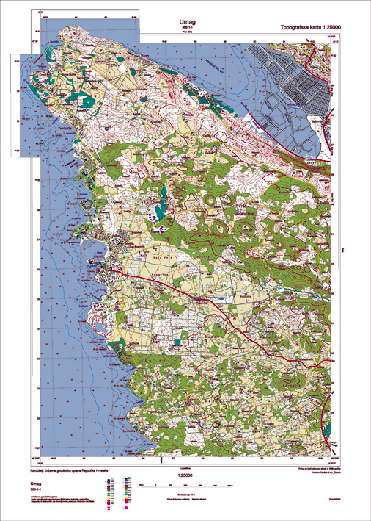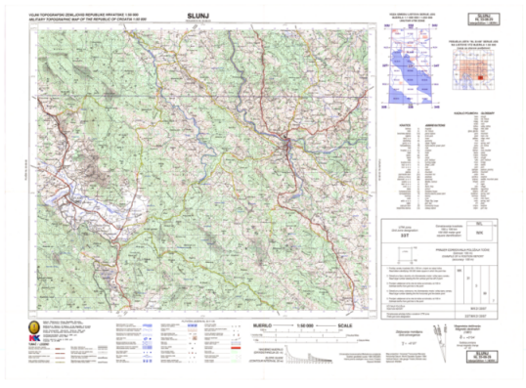
SGA CROTIS
TDB

MoD
VoGIS

SGA
TM 25

AF

TLM50
JOG 250

VMap 1
JOG A
DTED

Figure 5. Relation of civil and military geoinformation systems (MoD 2004)

By using the CROTIS model MoD will join SGA in creating of new cartographic system which will be based on the Fundamental Topographic database. At the same time the model based on the updating of existing (old) maps will abandoned.
Of great importance is the interoperability of a system that enables data exchange between the Croatian state institutions and between the members of the NATO and the Partnership for Peace.
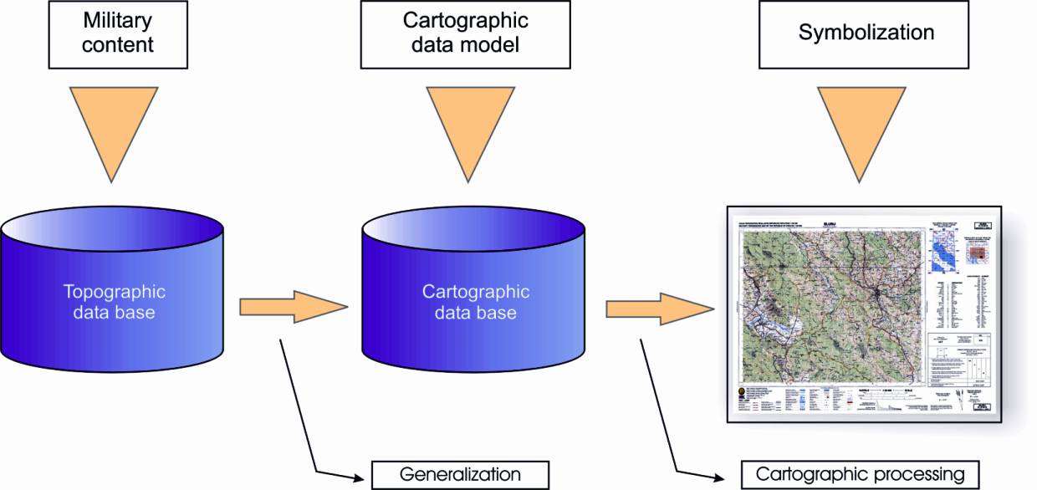
Figure 6: Map production scheme
Original proposal (MoD 2004.) defines states implementation steps which should be adjusted during the execution of the project according to obtained knowledge and technology. The topographic database model is the main result of the first phase of the project. From the scheme of cartographic production (fig. 6), two main phases of production can be seen: a generalization (creation of cartographic database) and cartographic processing (assignation of symbols, styles, etc). Precondition for data exchange between various institutions will be production of detailed exchange models, according to which particular data structure will be mapped to another data structure.
These exchange models are:
- model for mapping data from CROTIS system to the VoGIS topographic database
- model for mapping cartographic database from VoGIS system to CROTIS system of SGA
- model for data exchange according to NATO standards.
Access to VoGIS databases will be possible trough an application server (fig. 7). With export functions of GIS tools and custom made applications, users who will need own copies of the whole database or part of the database, will be able to obtain them.

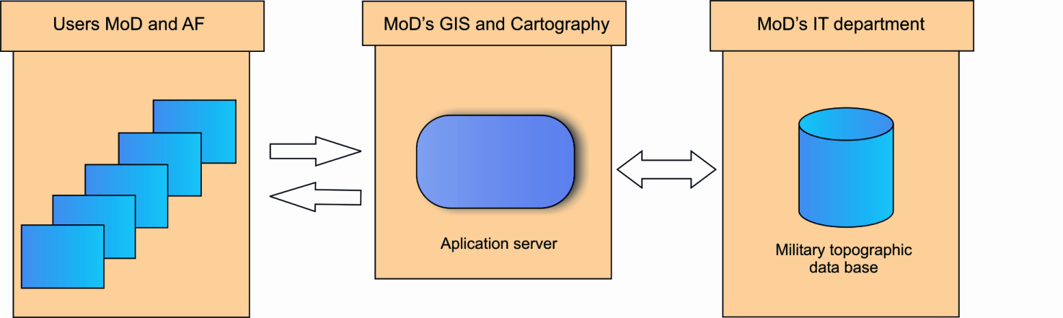

Figure 7: Direct access to the topographic database
- NORMS AND STANDARDIZATION
Standards/norms in geoinformation are delivered by competent institutions and organizations. During creation of this project, different standards and norms were used. The norms are from the geoinformation field, issued by the Technical Committee ISO/TC 211 (URL 1), the NATO and from the Open Geospatial Consortium - OGC (URL 2).
In the Republic of Croatia, the Product specification for topographic data (SGA 2003) which is based on CROTIS standard (SGA 2000) is used as standard for collection, processing, presenting and exchange of topographic data. As ISO norms and specifications regulated by OGC were already described on several occasions in other works, in next section can be found short explanations of NATO norms used in this project.
The Digital Geographic Information Working Group (DGIWG) was established in 1983 to develop standards which would enable efficient data exchange between the NATO member states (DGIWG 2000). DGIWG is not an official NATO body, but its work on standards is recognizable and approved by the NATO Geographic Conference (NGC).
This working group has developed the DIGEST (Digital Geographic Information Exchange Standard) as an exchange standard (URL 3). DIGEST, as a standard, supports exchange of raster, matrix and vector digital geographic data between producers and users. Moreover, the standard supports entire sequence of topological structures. From 1990’s until today, DIGEST became NATO standardization agreement number 7074 (STANAG 7074). When modeling military topographic database, existing features from the SGA topographic database (SGA 2003.) are mapped to the features of the VoGIS model; by usage of definitions from the FACC catalogue.
- NATO norms
Forth part of the DIGEST standard consists of the catalogue of feature and attribute codes - FACC (Feature and Attribute Coding Catalogue). FACC catalogue has been used as the base for modeling and encoding of military objects of topographic database.
When modeling military topographic database, existing features from the SGA topographic database (SGA 2003.) are mapped to the features of the VoGIS model; by usage of definitions from the FACC catalogue.
Large numbers of features from existing SGA database have not been simply translated (one to one) to VoGIS. Explicitly, for a feature from topographic database does not always exists an adequate feature in FACC catalogue that could be accepted as a new VoGIS feature. Therefore, features from topographic database were mapped to a VoGIS features by combination of values defined in the FACC catalogue for features, attributes and attribute values. By establishment of relations between features, attributes and their values, the VoGIS topographic database model version 1.0 has been made.
VoGIS catalogue has been harmonized with the FACC catalogue as much as possible, so when specific features from the topographic database aren’t defined in FACC catalogue; a new VoGIS codes are created according to the FACC catalogue.
As FACC is just a dictionary and does not specify data model and does not provide relations between features and attributes, for creation of a data model additional NATO standards based on FACC were used. These are: Digital Topographic Data - DTOP (NIMA 2002.), Vector Map Level 1 - VMap1 (NIMA 1995.), Vector Map Level 2 – VMap2 (DMA 1996.), Urban Vector Map – UVMap and many other standards.
Existing data from topographic database together with mentioned NATO norms were used as a foundation for development of the VoGIS database. That way, to please all demands, original FACC catalogue was extended and VoGIS catalogue was made.
- CONCLUSION
Republic of Croatia started many activities with the goal to create national spatial data infrastructure. From the technical, technological, organizational, financial and implementable side those activities are carried out by experts from geodetic companies, science and educational organizations and state bodies guided by the State Geodetic Administration.
Production of spatial data has started; first experiences enabled geodesists to improve used documents and technology procedures.
One of the main principles in the e-Croatia concept, which has been established by the Government of the Republic of Croatia, is collection of a data once and its multiple usages. As the State Geodetic Administration, based on the Program of State Survey and Real Estate Cadastre has already began activities related to creation of the spatial information system, it was logical to use these data in the military geoinformation system as well. Therefore, the project CROTIS has been taken into account as the standard and the groundwork, for establishing of the military geoinformation system faster and more rational.
REFERENCES
- State Geodetic Administration (2001a): Croatian Topographical Information System, ver. 1.1., Zagreb, Croatia
- State Geodetic Administration (2001b): Ordinance on Topographic Survey Methods and State Map Production, Official Gazette, no 55, Zagreb, Croatia
- State Geodetic Administration (2003a): Product Specification Topographic Data 1.0, Zagreb, Croatia
- Lemajić , S., Rožić , N., Rapaić , M. (2003): Improvement of Quality Control System in Croatia, Proceedings of the ISPRS WG VI/3 Workshop 2003, Zagreb, Croatia
- Pavičić S.. Rapaić M., Lemajić S. (2004): Topographic Data Production as Basis for NSDI - Croatian Example, FIG Working Week 2004, Athens, Greece
- Digital Geographic Information Working Group (2000): Digital Geographic Information Exchange Standard (DIGEST) Edition 2.1. STANAG 7074, DGIWG, SAD
- State Geodetic Association (2000): CROTIS Temeljna načela – katalog objekata, verzija 1.0, Geofoto d.o.o., Zagreb
- Defense Mapping Agency (1996): Performance Specification - Vector Smart Map (Vmap) Level 2 - MIL-PRF-89032 Draft, DMA, SAD

